To create new repo and upload it

Create a repository/folder in GitHub site

Steps:

Click on highlighted part

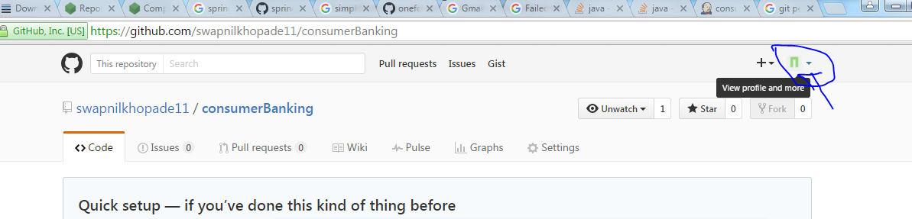

Click Explore for create new Repo

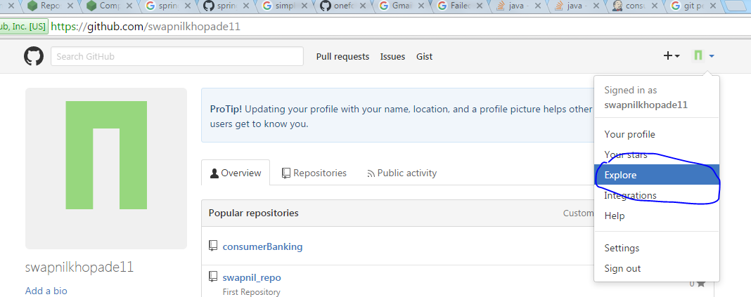

Click on Highlighted part

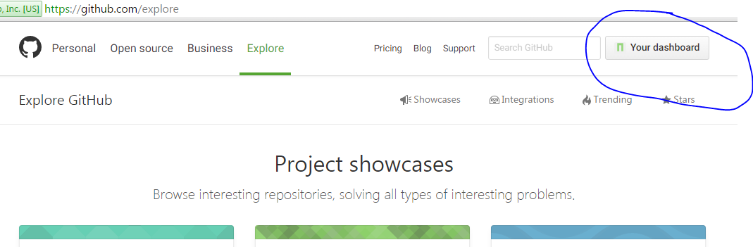

Start a Project

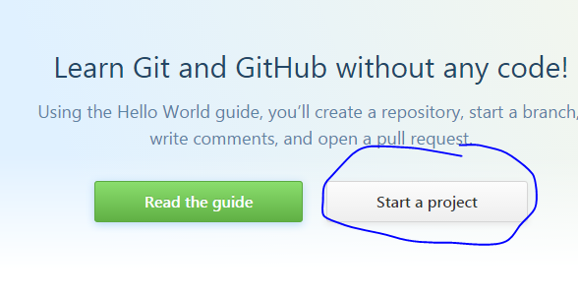

Provide Repo Name

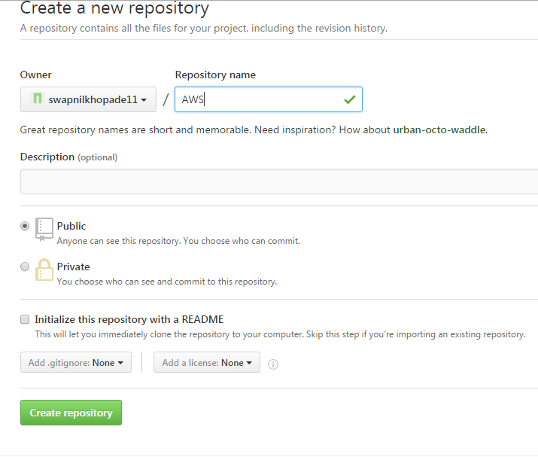

Use Belo repository Url for code access and checkin checkout.

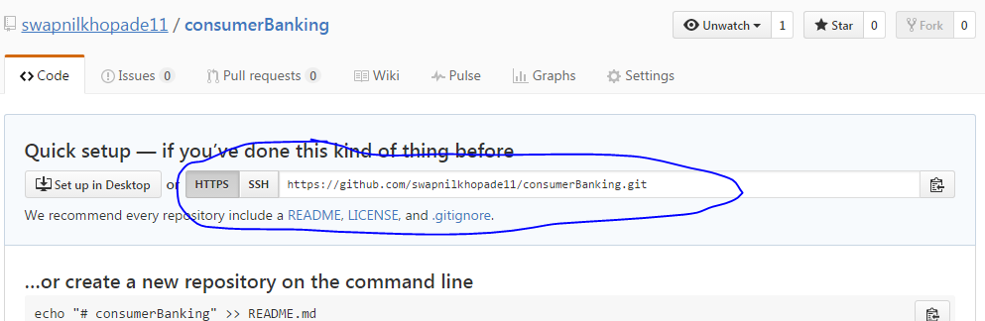

Now Install Git

Write Steps Here:

Open Project location:

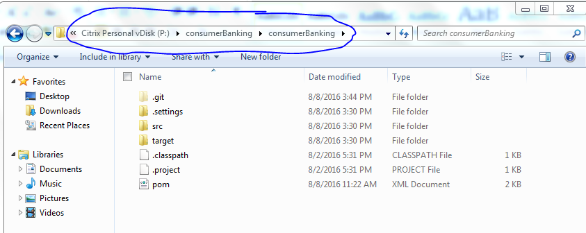

Go inside that location.

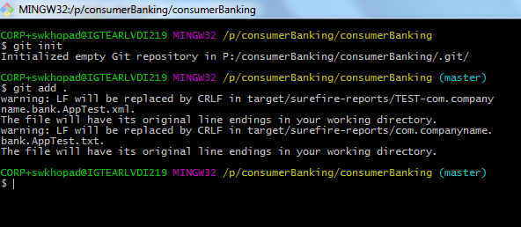

Search steps on google for push the code into github:

In google search using below querry.

“pushing your code on github through gitbash”

**Direct URL:** https://help.github.com/articles/adding-an-existing-project-to-github-using-the-command-line/

1. Command (git init)

This will Initialize the local directory as a Git repository and create .git file into the repository

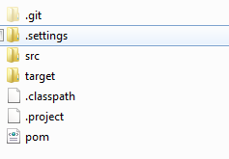

Now Follow the above URL steps.